Árbol Binario
81
103
100
63
76
87
28
25
31
27
29
15
233
3333333333333333
5
3
L2

L3

d
L1

Codigo en LISP
Setq E ‘(33(15 3 5) (29 (27 25 28) 31 ) ) (87 (76 63 81)(100 101)))
Setq l1 (cddadr E)
Setq l2 (caddr E)
Setq l3 (cadadr E)
Setq X (list 33 (list 23 l3 l2) l1)

2.-
CL-USER 9 > setq P'( 60 ( 42 ( 14 2 ) ( 54 ( 49 ( 58 59 )) ) ) ( 75 ( 66 ( 73 72 )) ( 85 83 (90 87 98 ))))
(60 (42 (14 2) (54 (49 (58 59)))) (75 (66 (73 72)) (85 83 (90 87 98))))

CL-USER 14 > setq x1 (car(cdadar(cddadr P)))
(58 59)

CL-USER 15 > setq x2(cadar (cdaddr p))
(73 72)

CL-USER 16 > setq x3(cadadr p)
(14 2)

CL-USER 17 > setq x4(cadr(cdaddr p))
(85 83 (90 87 98))

CL-USER 18 > setq A(list 60(list 42 x2 (list 54 49 x4))(list 75 (list 66 x3) x1) )
(60 (42 (73 72) (54 49 (85 83 (90 87 98)))) (75 (66 (14 2)) (58 59)))

3.-
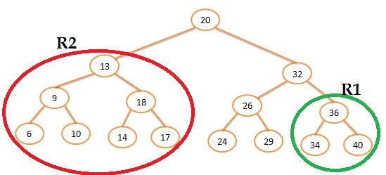

setq A '(20 (13 (9 6 10) (18 14 17)) (32 (26 24 29) (36 34 40)))
A = (20 (13 (9 6 10) (18 14 17)) (32 (26 24 29) (36 34 40)))
setq R2 (car(cdr A))
R2 = (13 (9 6 10) (18 14 17))
setq R1 (car(cdr(cdaddr A)))
R1 = (36 34 40)
setq R3 (car(cdaddr A))
R3 = (26 24 29)
Finalmente procedemos con la cirugía
Setq X (list 20 R1 (list 32 R3 R2) )
X = (20 (36 34 40) (32 (26 24 29) (13 (9 6 10) (18 14 17))))

